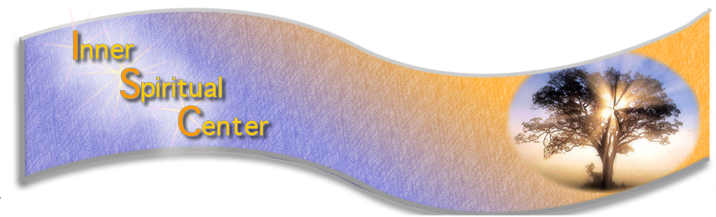
info@innerspiritualcenter.org www.innerspiritualcenter.org
Located at Fairfield Business Park- 333 Route 46 West, Building A #255 Fairfield NJ

INNER SPIRITUAL CENTER’S
2026
STUDENT DEMONSTRATION of Mental Mediumship

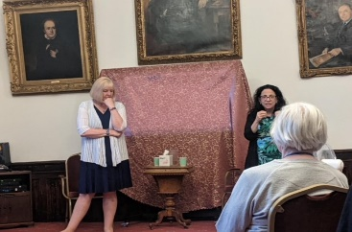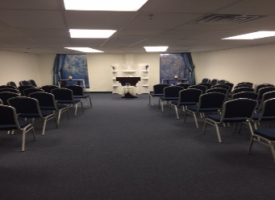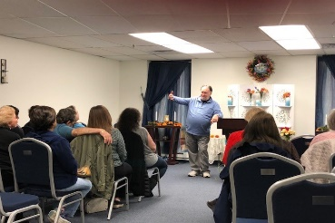
Rev. Sharon ISC Center in NJ Rev. Bill Coller
Join some of our 2026
2nd year, 3rd year and Advanced Mediumship Students
via Zoom or In Person
No Charge Event but Registration is required if you are not a current 2026 Mediumship Student
November 20th 2026 6:30 pm – 8:00 Pm Eastern

Gallery style Demonstration of Contacts from Spirit. Please note that there is no guarantee of individual contact/reading.

Must register on our website for this event. There will be no admittance on zoom or in person without being registered as this is a No Charge Event. Registration ends on 11/15 10pm Eastern

This is an important event for our students as they incorporate the techniques of Mediumship and Demonstration that they have been working on in this course. We appreciate your support and giving them an opportunity to work. The Demonstration is monitored by Rev. Bill Coller and/or Rev. Sharon Siubis who are the course teachers and co-founders of the Inner Spiritual Center along with some of our Advanced Students.

In person admittance will start at 6 pm and doors will close at 6:30. Zoom room will open at 6:15 and be closed at 6:30.

